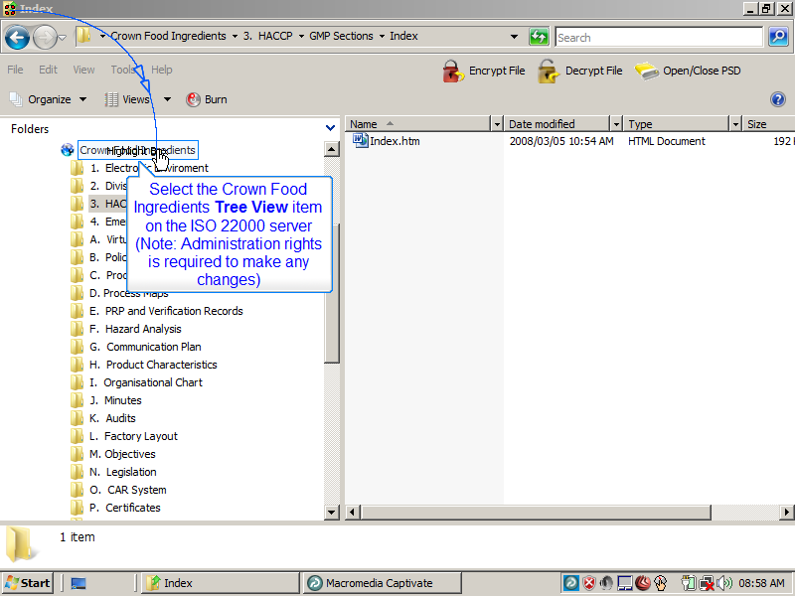
Slide 1
Note:
Select the Crown Food Ingredients Tree View item on the ISO 22000 server
(Note: Administration rights is required to make any changes)

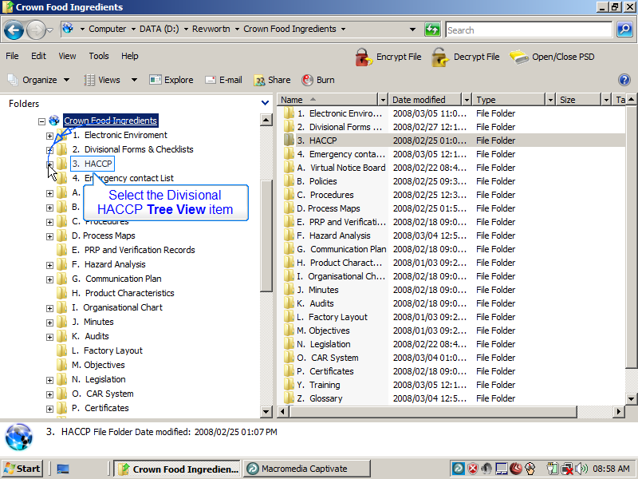
Slide 2
Note:
Select the Divisional HACCP Tree View item

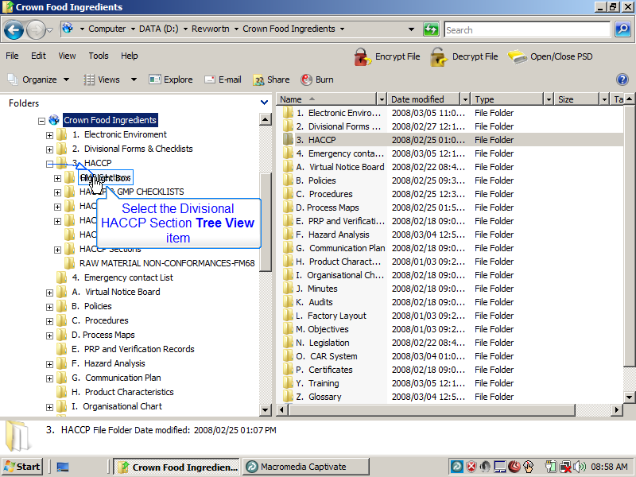
Slide 3
Note:
Select the Divisional HACCP Section Tree View item

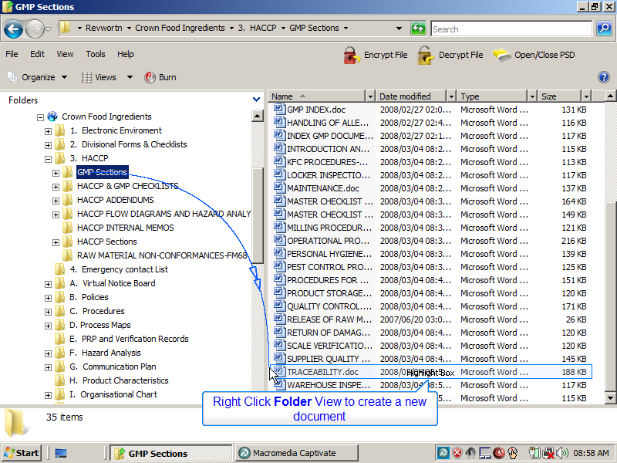
Slide 4
Note:
Right Click Folder View to create a new document

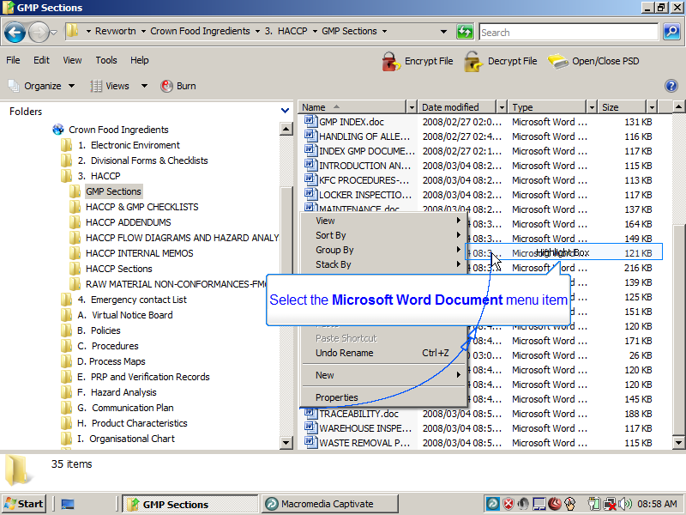
Slide 5
Note:
Select the Microsoft Word Document menu item

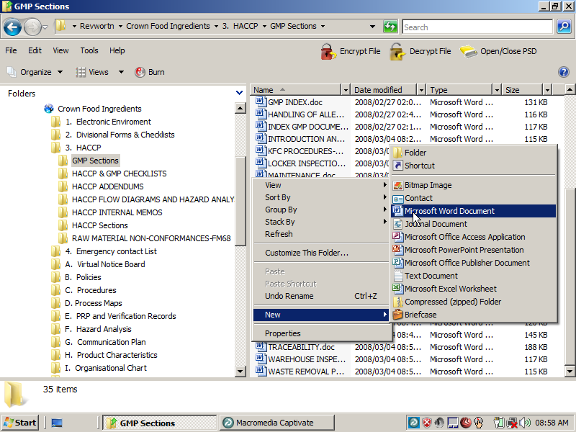
Slide 6
Note:

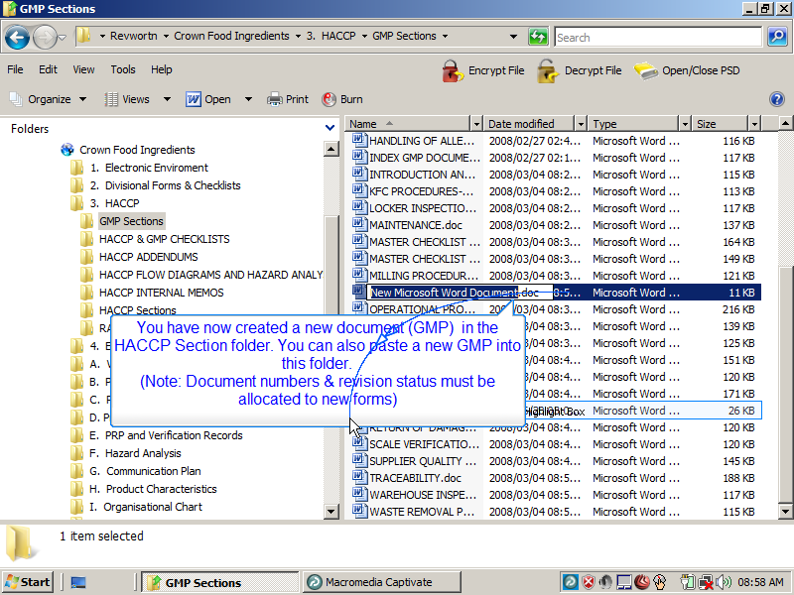
Slide 7
Note:
You have now created a new document (GMP) in the HACCP Section folder. You can also paste a new GMP into this folder.
(Note: Document numbers & revision status must be allocated to new forms)

Notes:

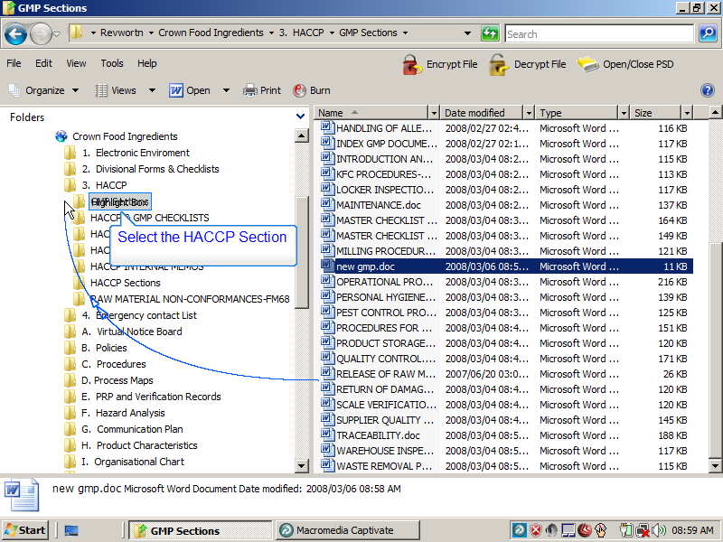
Slide 8
Note:
Select the HACCP Section Tree View item
Notes:

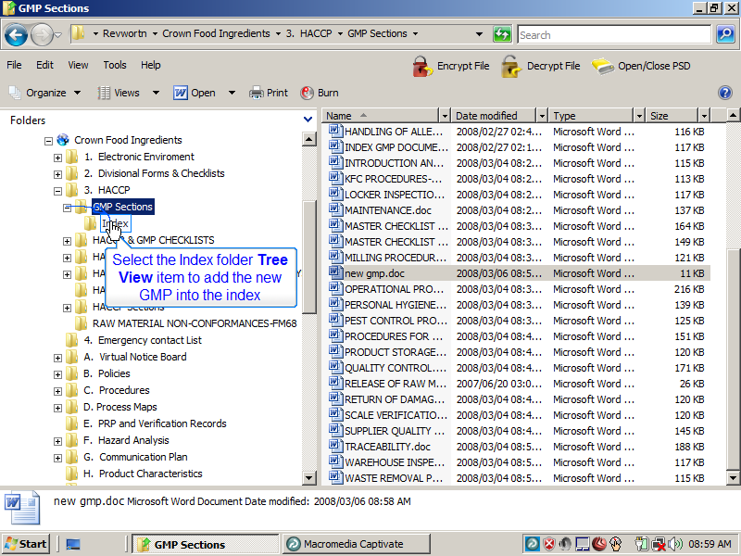
Slide 9
Note:
Select the Index folder Tree View item to add the new GMP into the index
Notes:

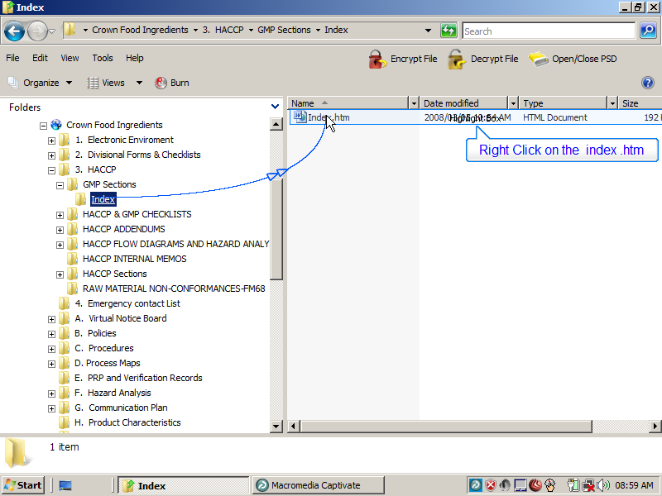
Slide 10
Note:
Right Click on the index .htm
Notes:

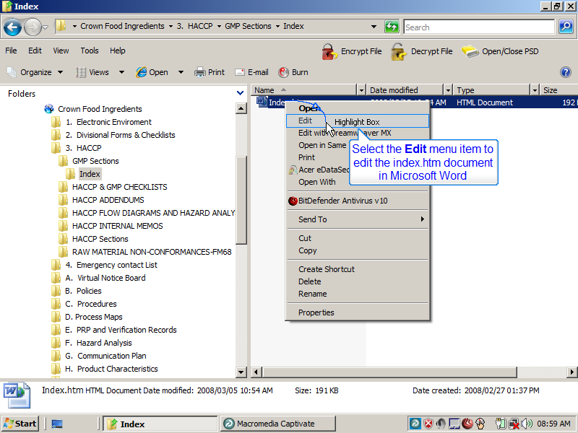
Slide 11
Note:
Select the Edit menu item to edit the index.htm document in Microsoft Word
Notes:

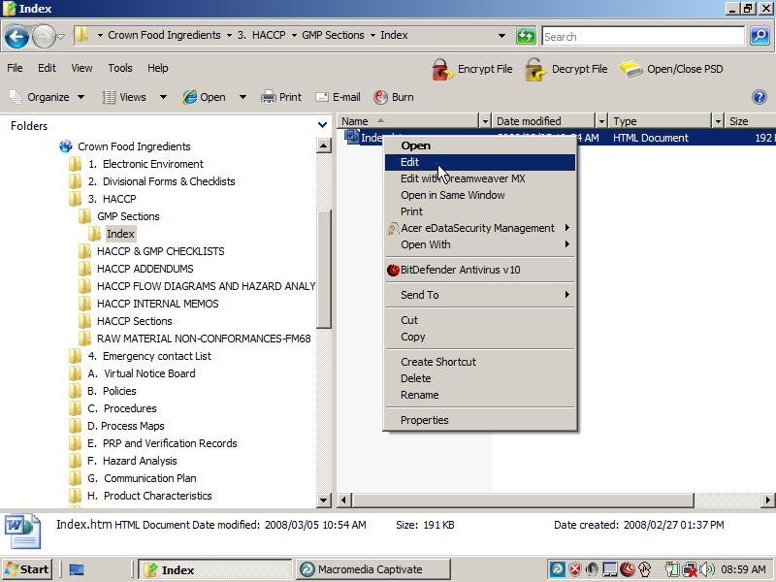
Slide 12
Note:
Notes:

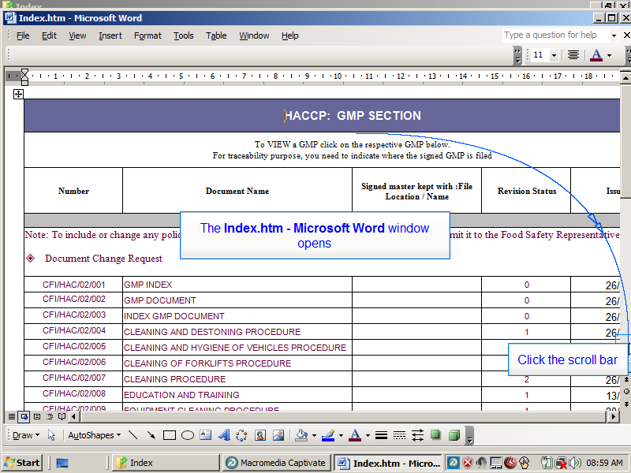
Slide 13
Note:
The Index.htm - Microsoft Word window opens
Click the scroll bar
Notes:

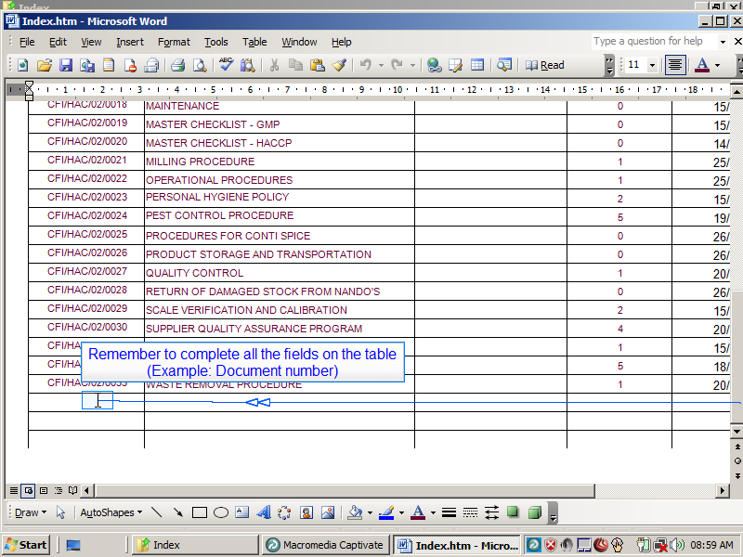
Slide 14
Note:
Remember to complete all the fields on the table
(Example: Document number)
Notes:

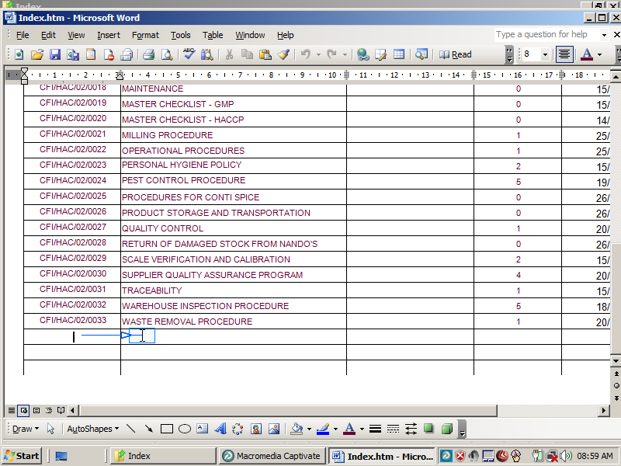
Slide 15
Note:
Notes:

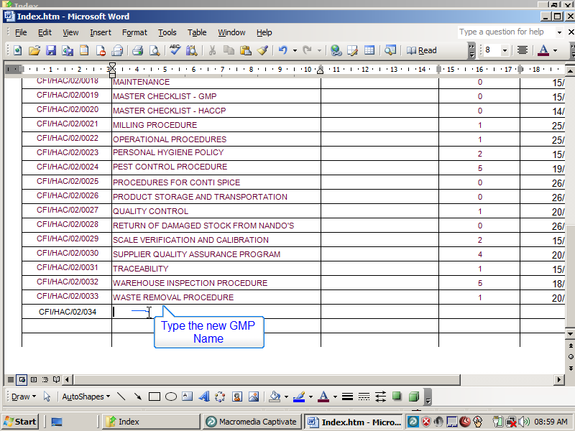
Slide 16
Note:
Type the new GMP Name
Notes:

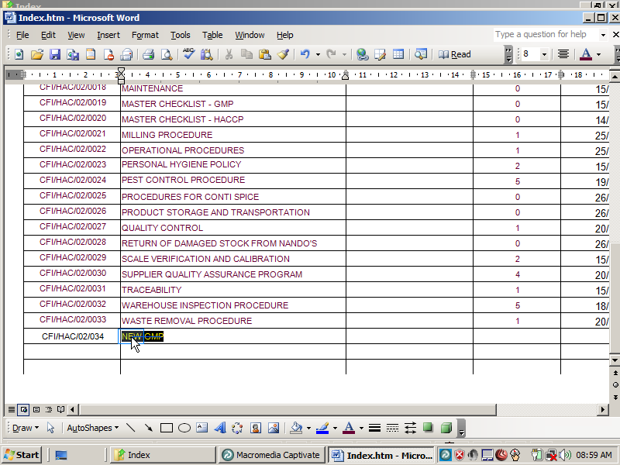
Slide 17
Note:
Notes:

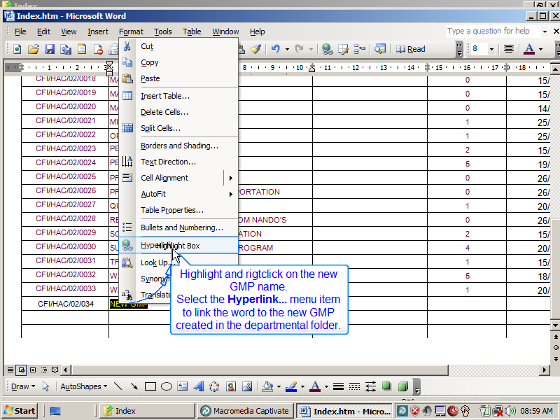
Slide 18
Note:
Highlight and rigtclick on the new GMP name.
Select the Hyperlink... menu item to link the word to the new GMP created in the departmental folder.
Notes:

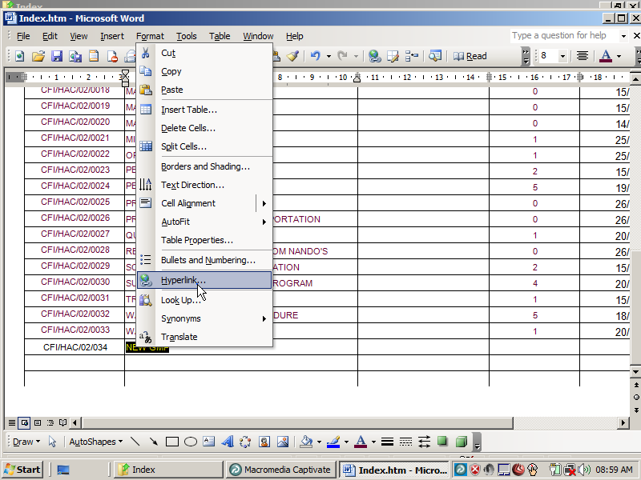
Slide 19
Note:
Notes:

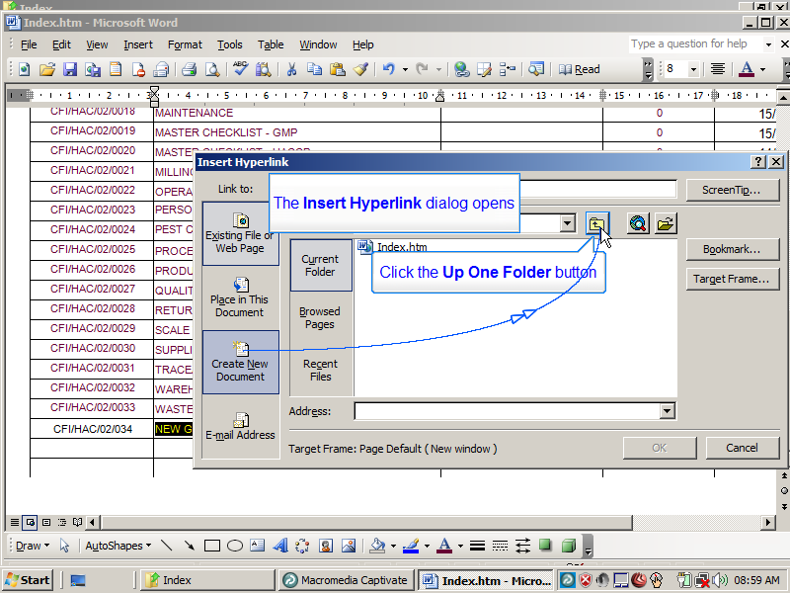
Slide 20
Note:
The Insert Hyperlink dialog opens
Click the Up One Folder button
Notes:

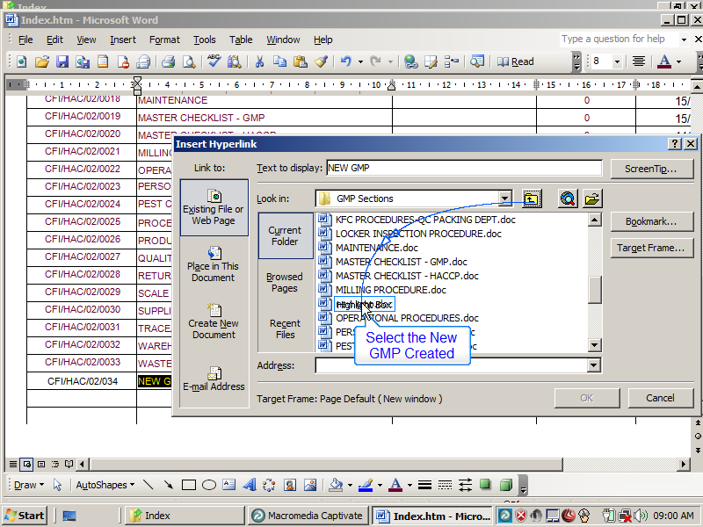
Slide 21
Note:
Select the New GMP Created
Notes:

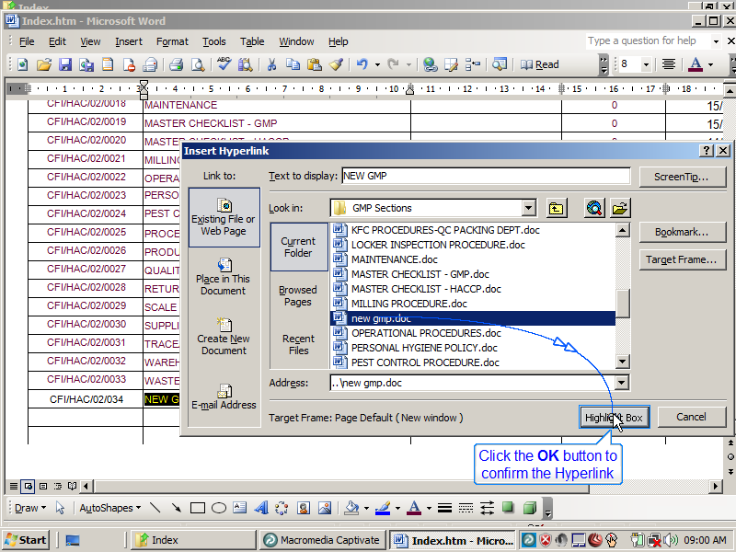
Slide 22
Note:
Click the OK button to confirm the Hyperlink
Notes:

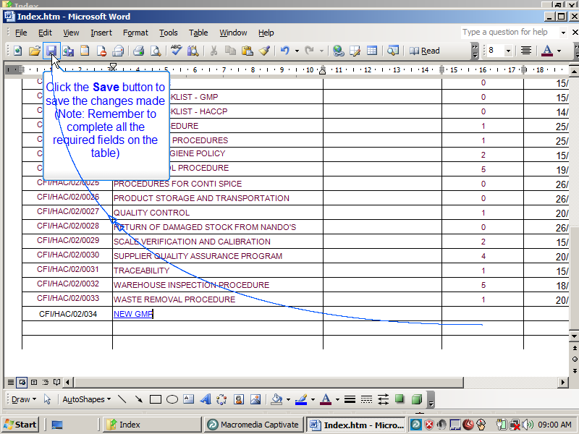
Slide 23
Note:
Click the Save button to save the changes made
(Note: Remember to complete all the required fields on the table)

Notes:

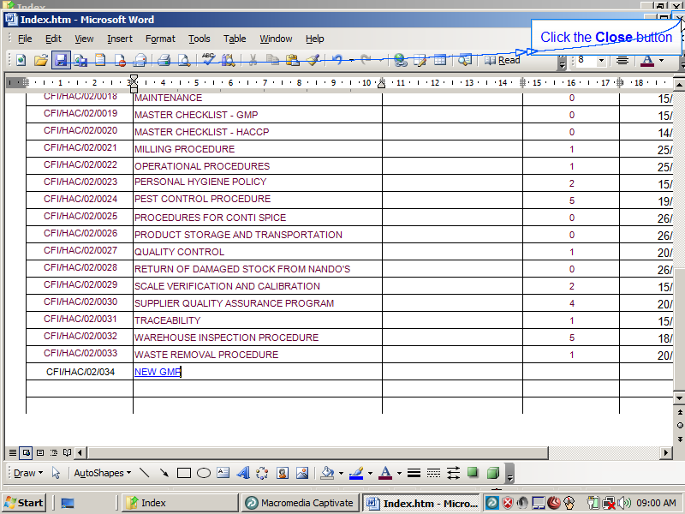
Slide 24
Note:
Click the Close button
Notes:

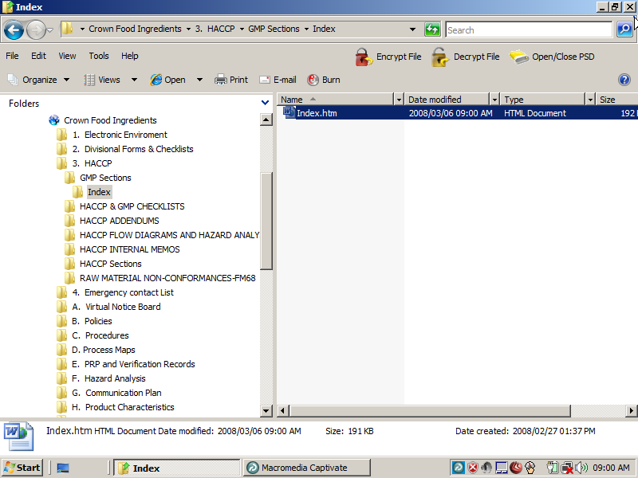
Slide 25
Note:
Notes:

